**Assignment 1: Build a Simple Network**

**Lelyan Saadeh 000922229**

**Assignment Summary:**

**This assignment involved designing and deploying a small virtual network for a fictional company, BeesKnees Inc., using VMware Workstation. The infrastructure included a Windows Server configured with Active Directory, DNS, and RRAS; a Linux server acting as a DHCP server; and two Windows clients joined to the domain. Each user was assigned a private, secure home directory mapped as the H: drive. I implemented hostname resolution across the network, enabled internet access via NAT, and ensured all systems could communicate using both IP addresses and hostnames. Hostname conventions and static/dynamic IP addressing were correctly applied according to the requirements.**

**Throughout this project, I gained valuable hands-on experience with server roles and services, domain configuration, NAT setup, and user management in a virtual environment. I also learned how to integrate Linux and Windows systems within a single network and troubleshoot connectivity issues. One challenge I overcame was properly configuring NAT and DNS resolution for internet access on machines without direct external connectivity—solving this required careful setup of RRAS and routing rules on the Windows Server.**

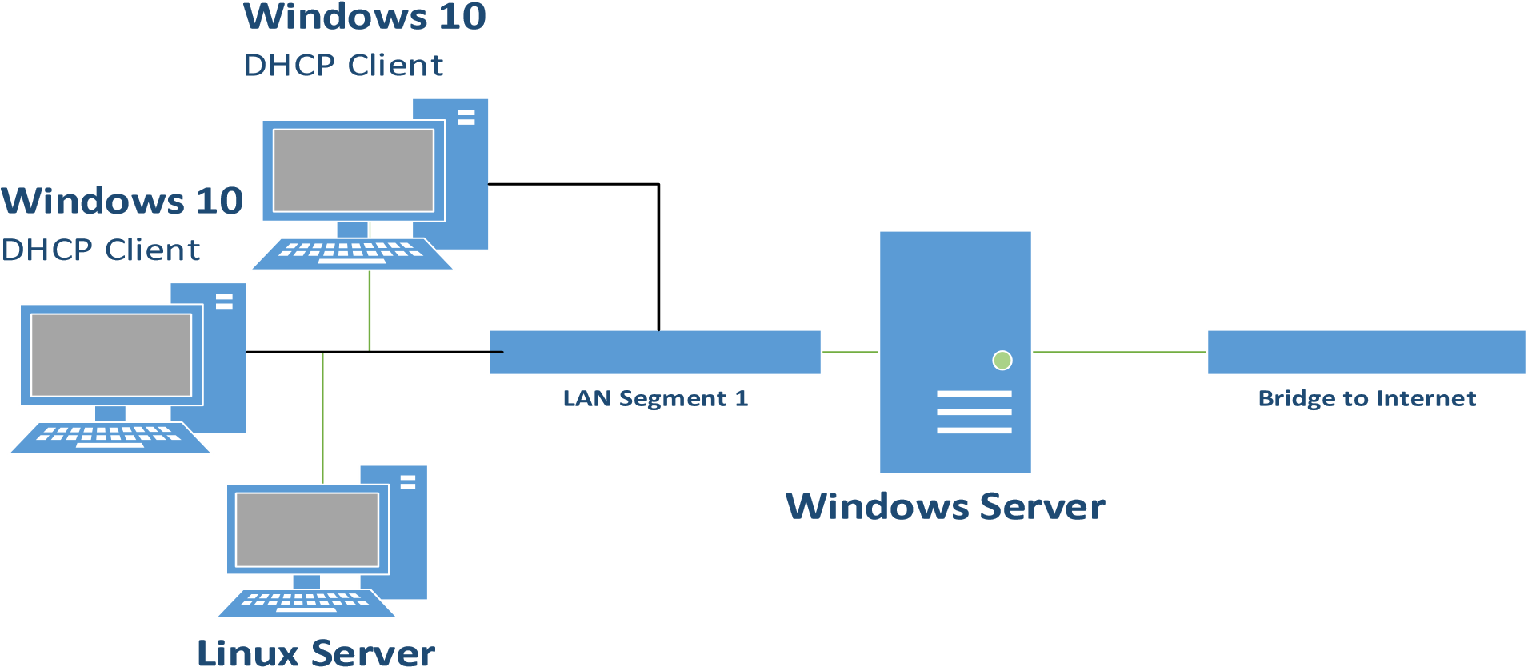

***screenshots:***

**VMWare Workstation -**

Of the VMWare Workstation layout, showing all machines created and the NIC connection for each VM.

Windows SERVER

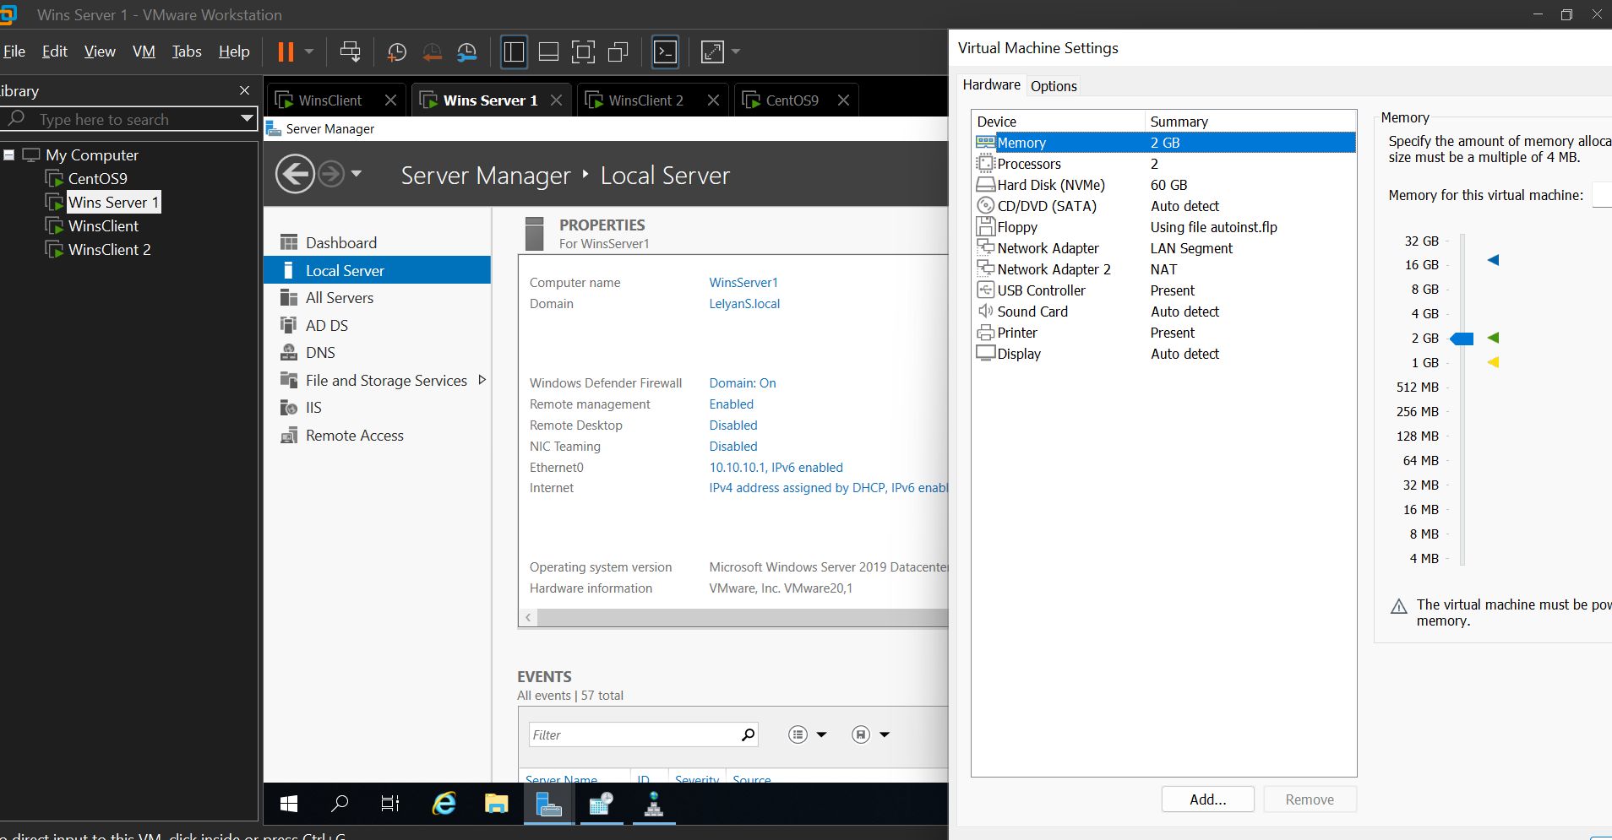

Linux DHCP SERVER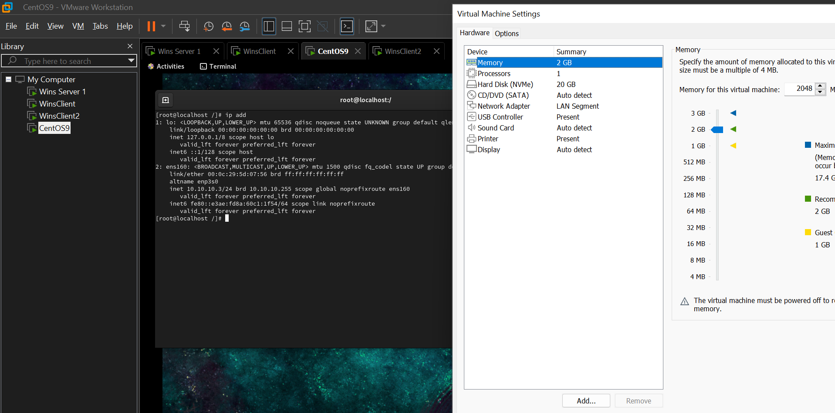

Windows Client1

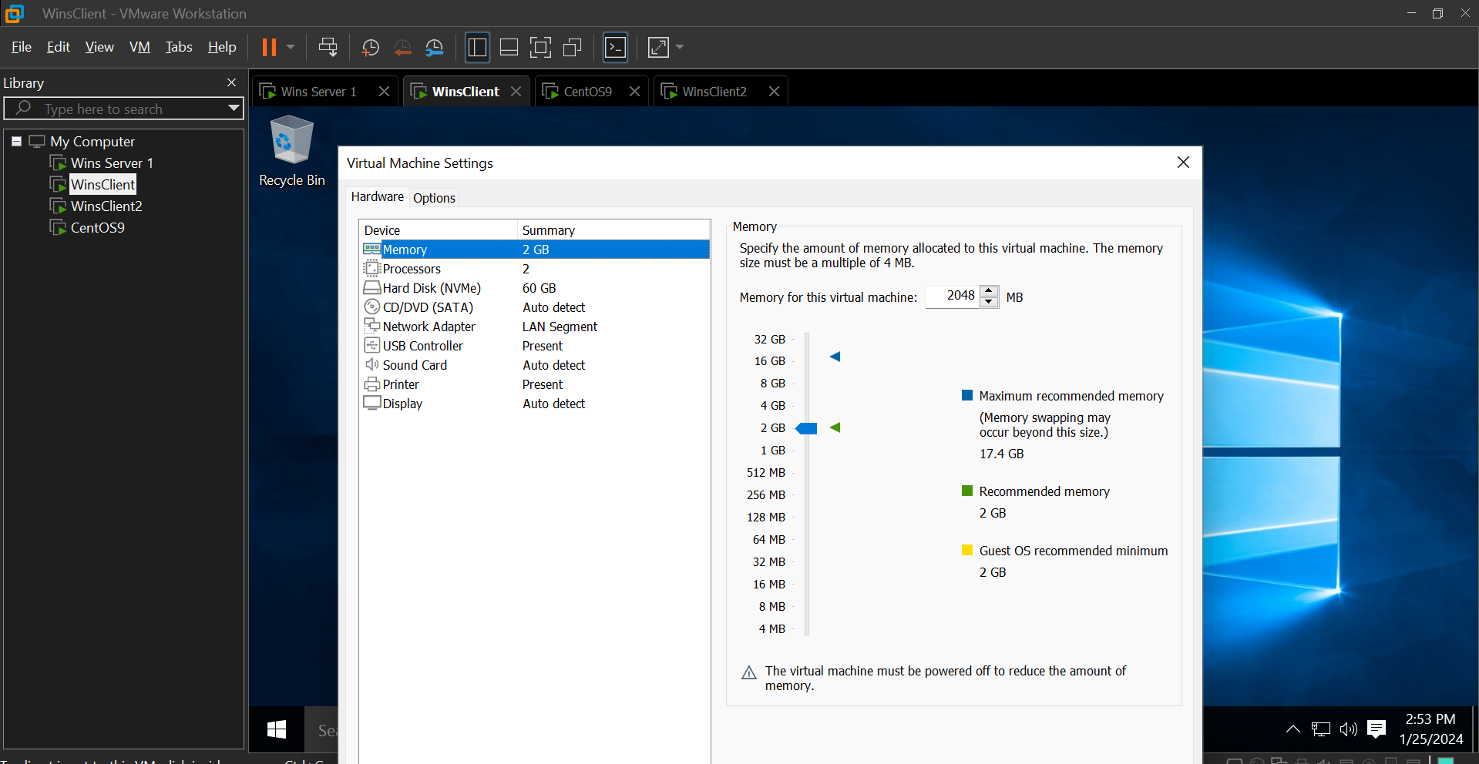

Windows Client2

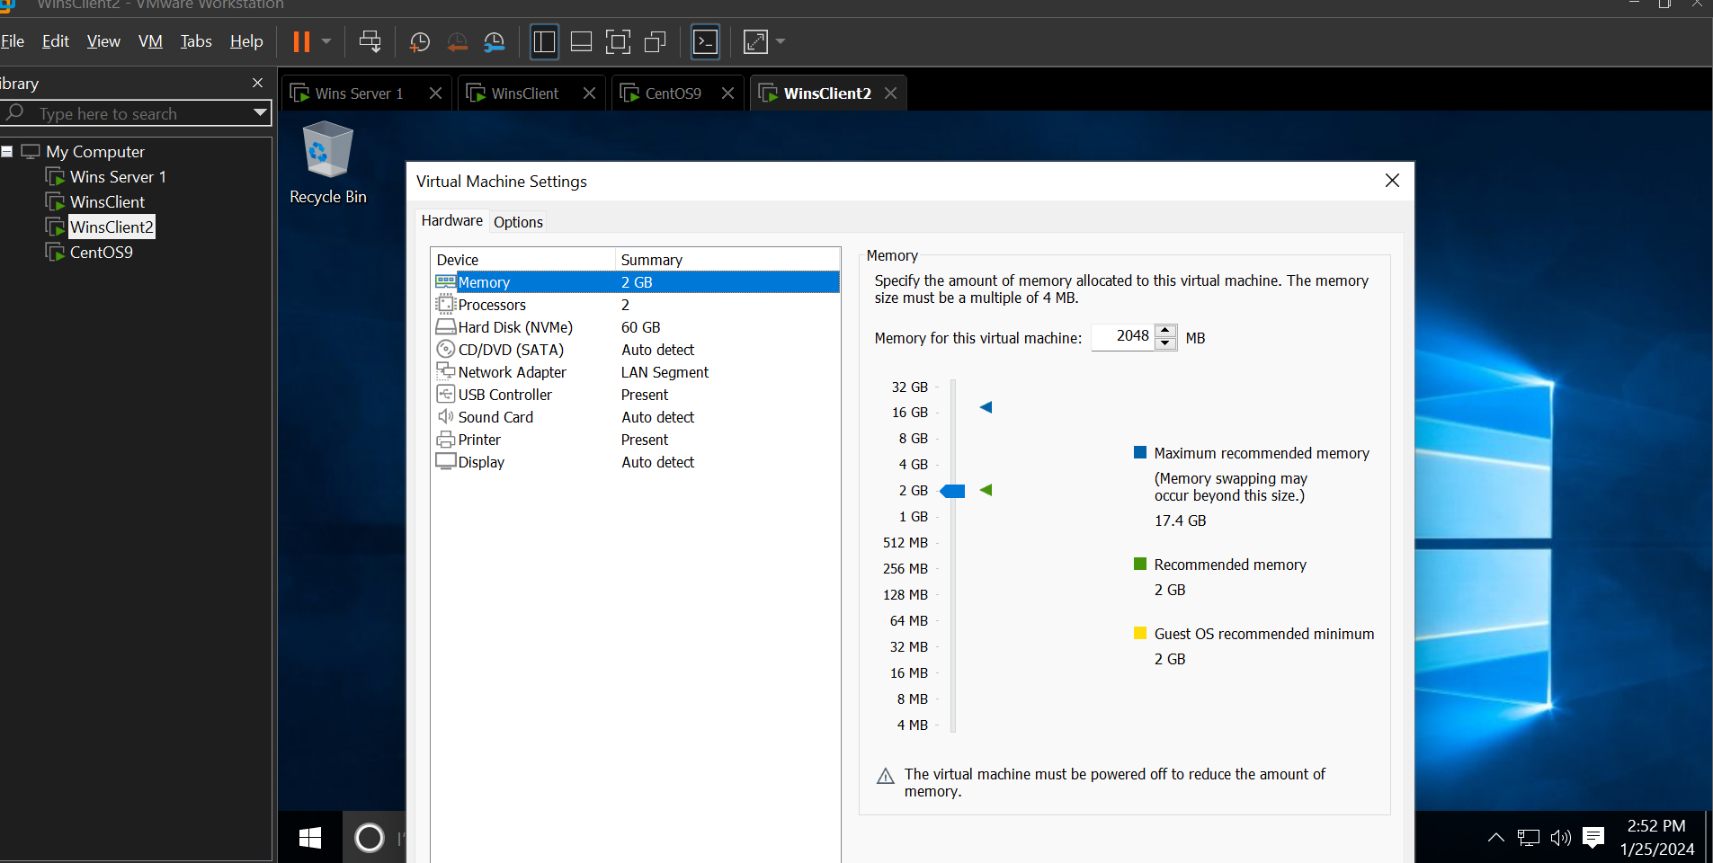

**Windows Server –**

screenshot of *AD Users and Computers* utility showing the two Windows client computers in AD, and the 5 created users.  
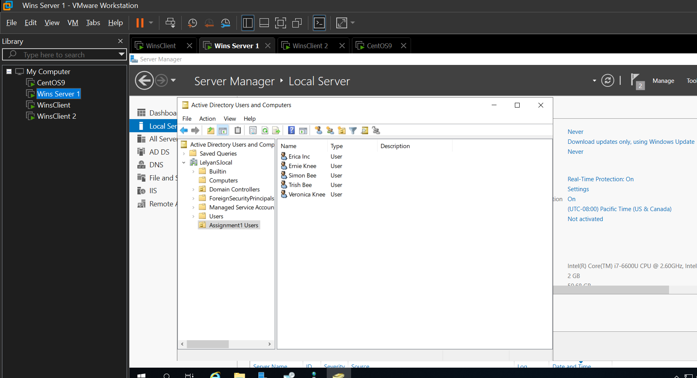

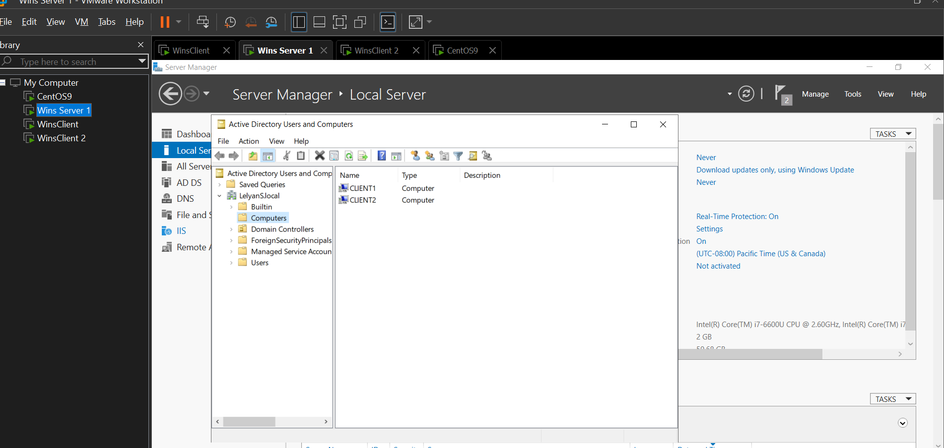

Content of forward lookup zones in DNS of domain

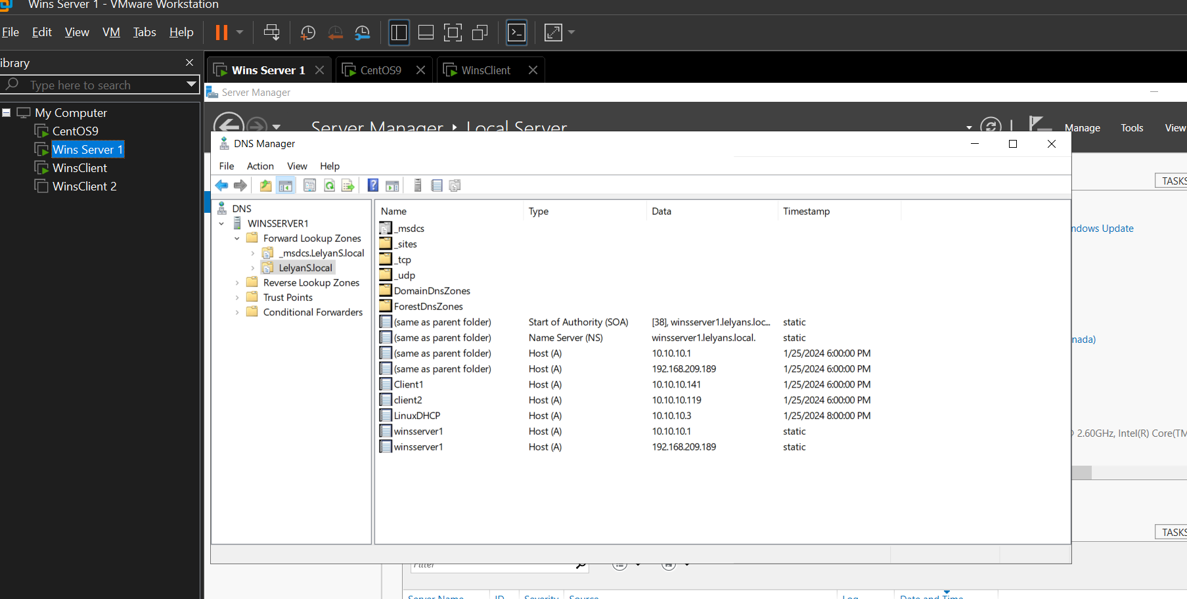

RRAS configuration with contents expanded to show NAT settings  
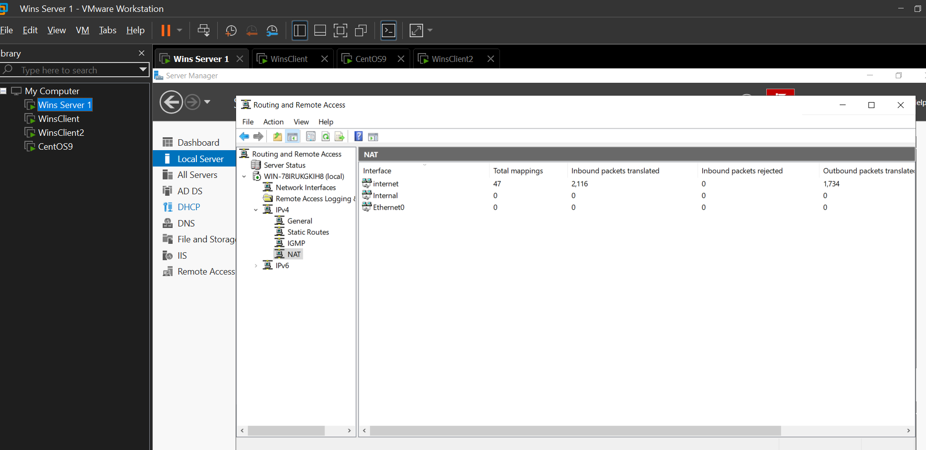

Output of “ipconfig /all” command

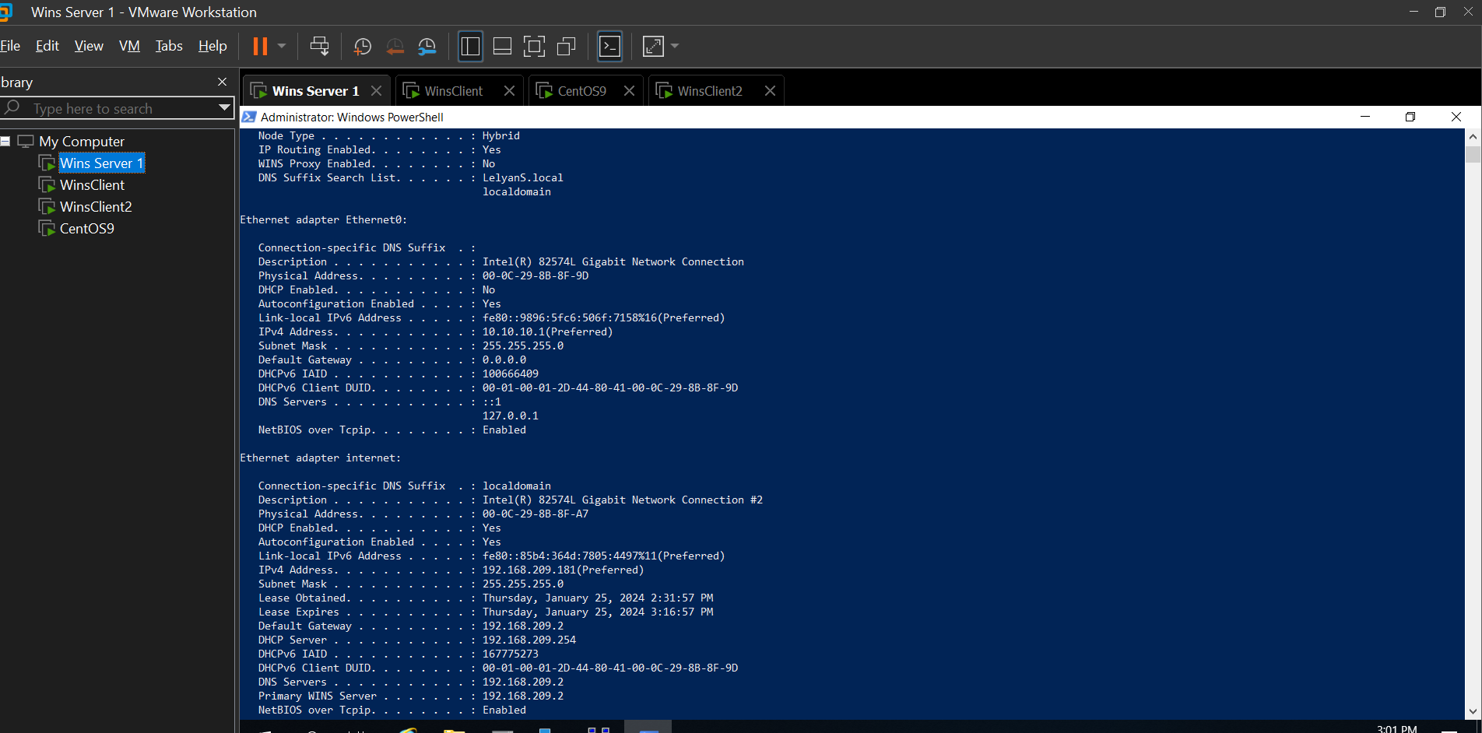

**Linux server -**

Output of “ip add”, “ip route”, “hostname” and “cat /etc/resolv.conf” commands showing static network configuration.

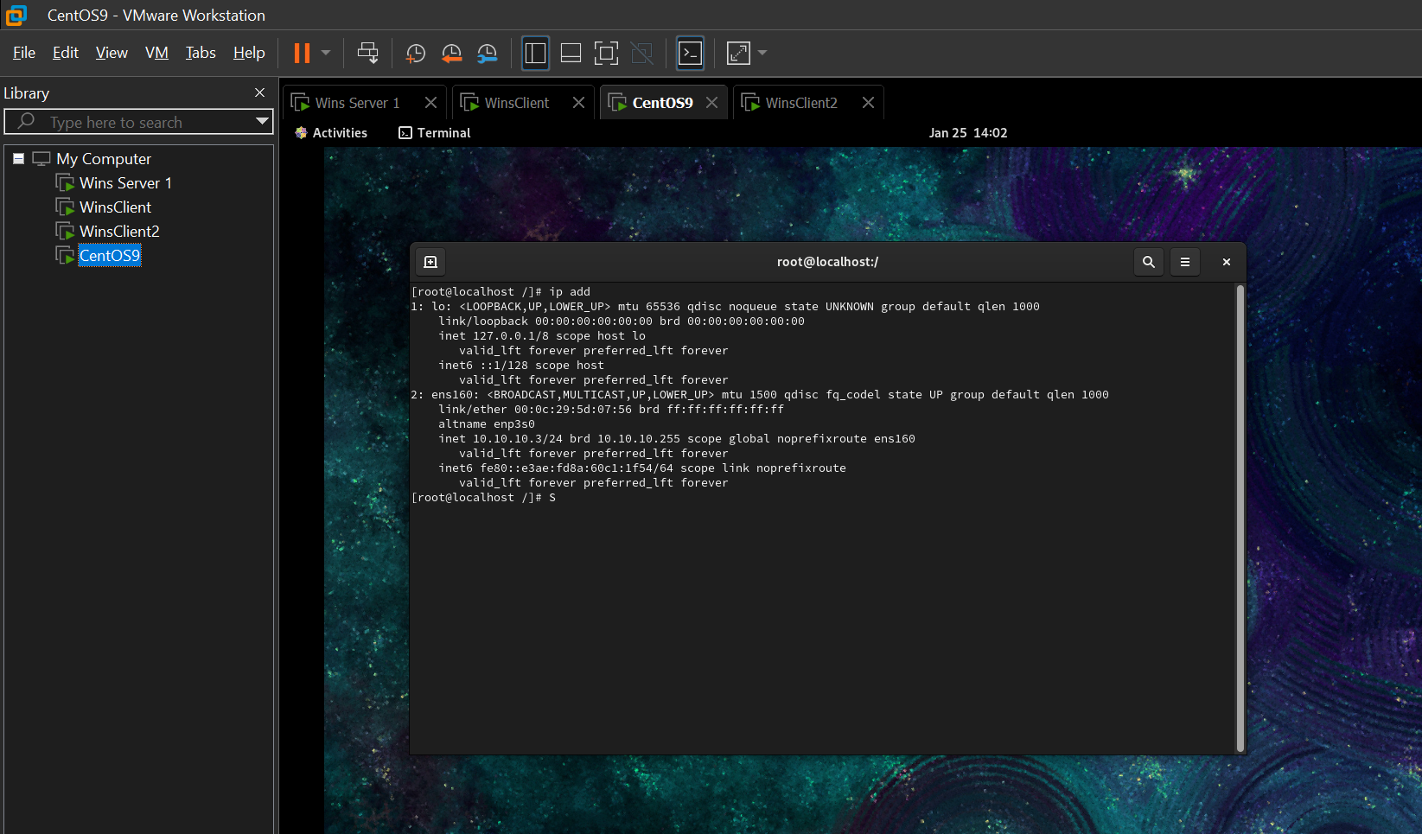

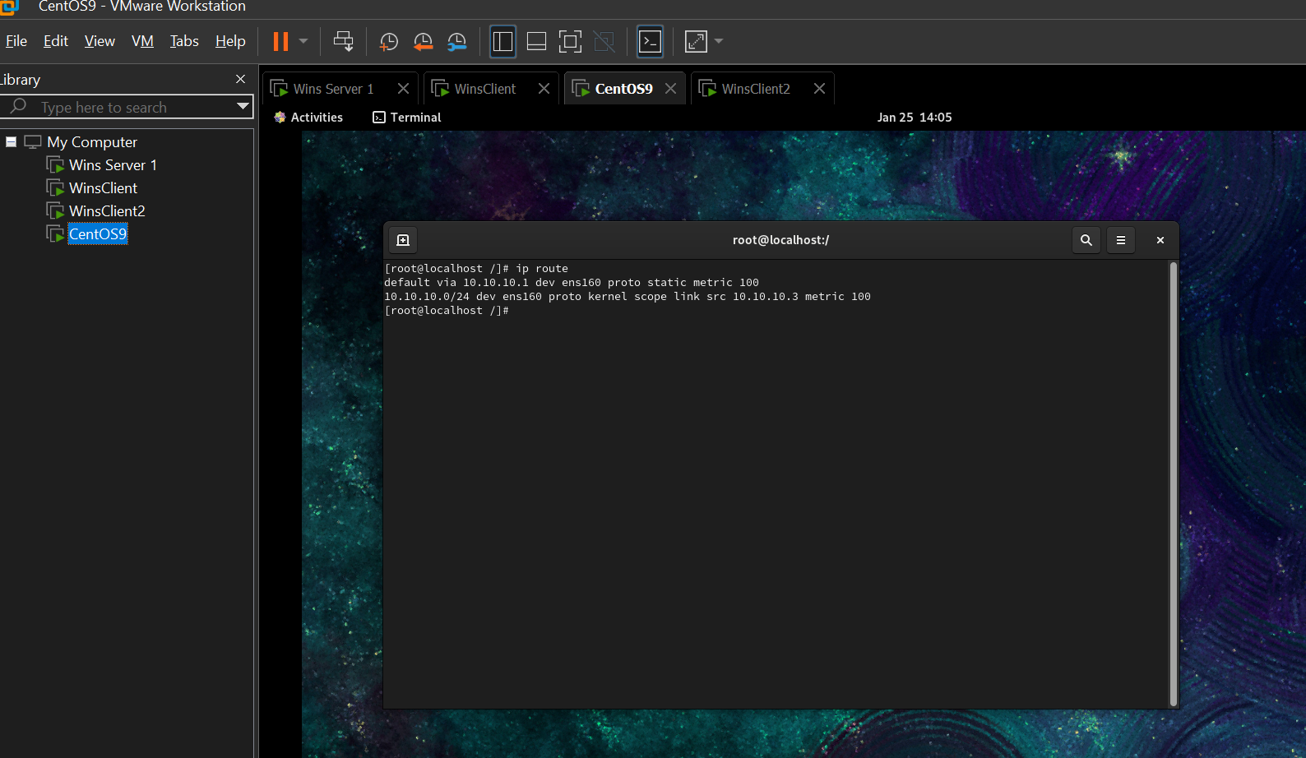

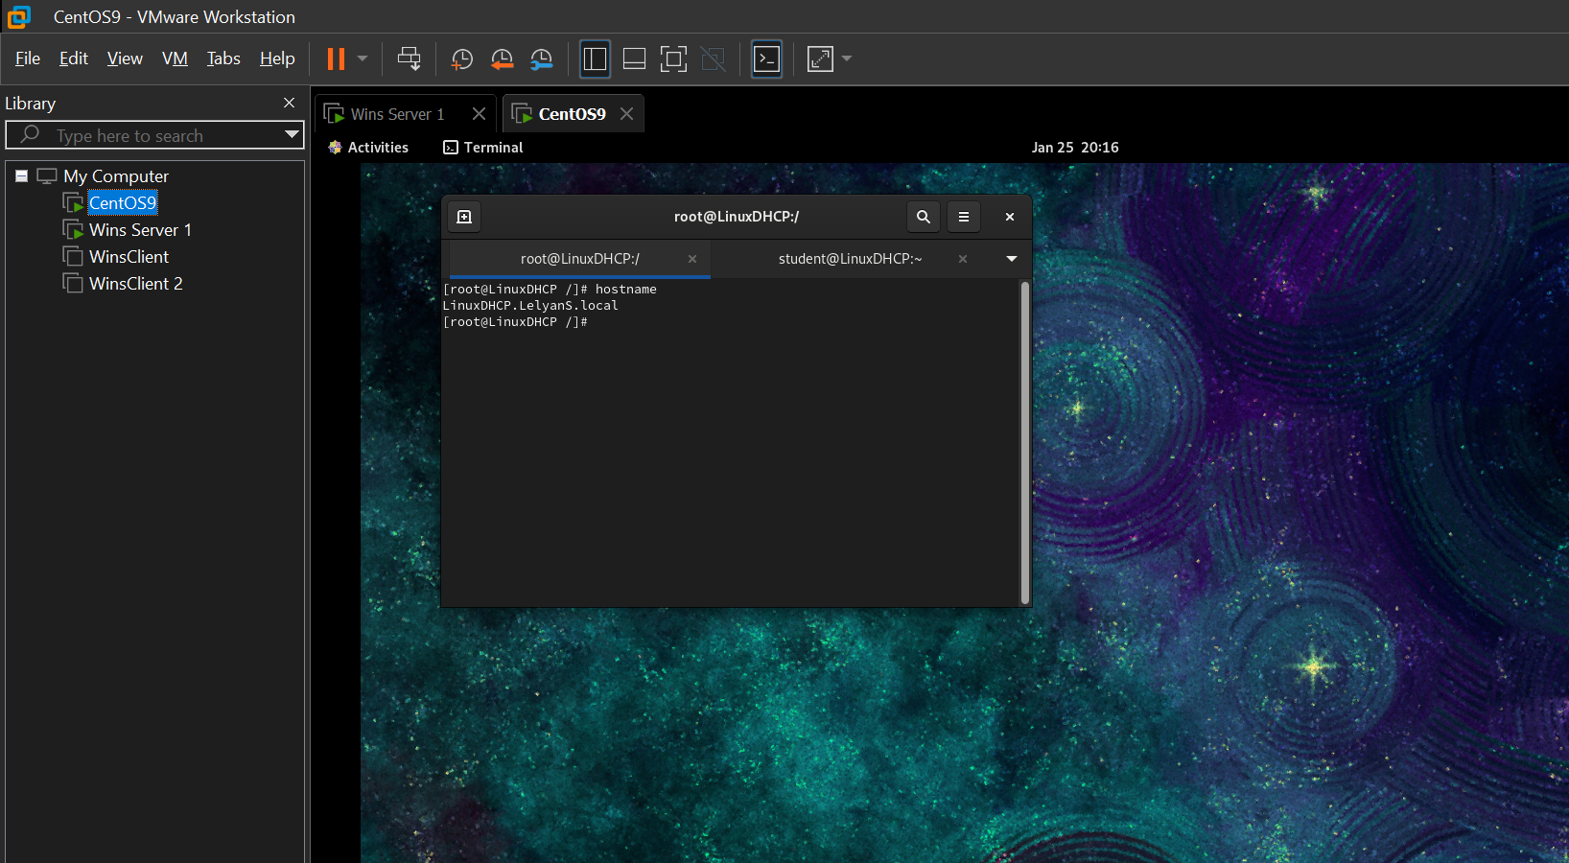

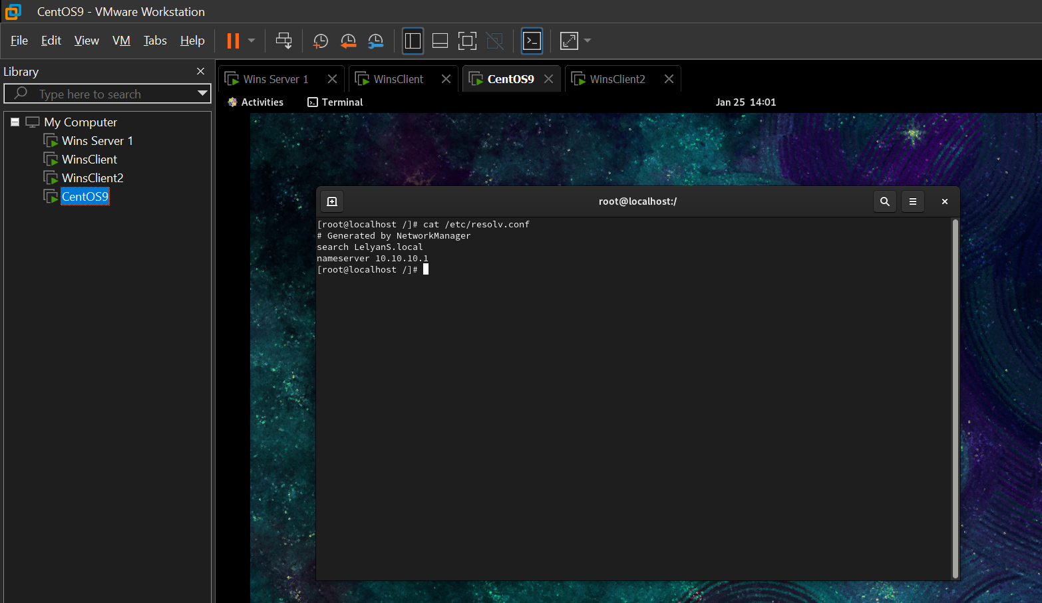

Demonstration of Internet access

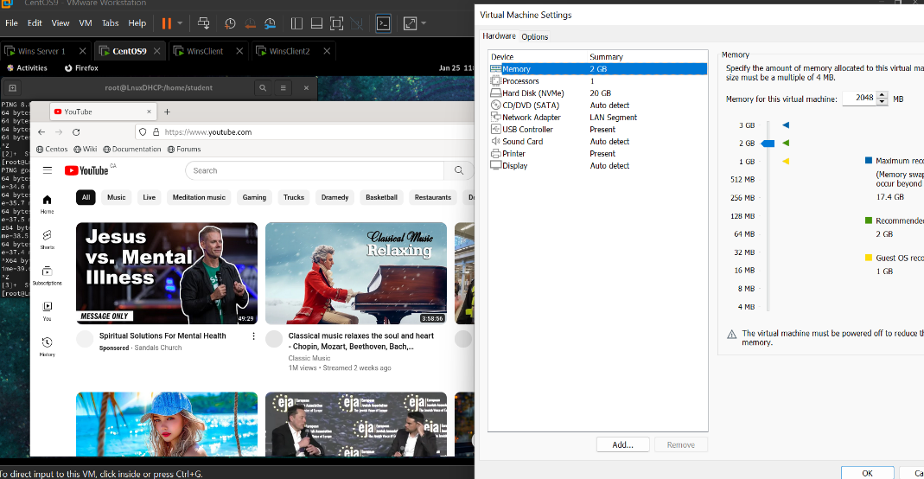

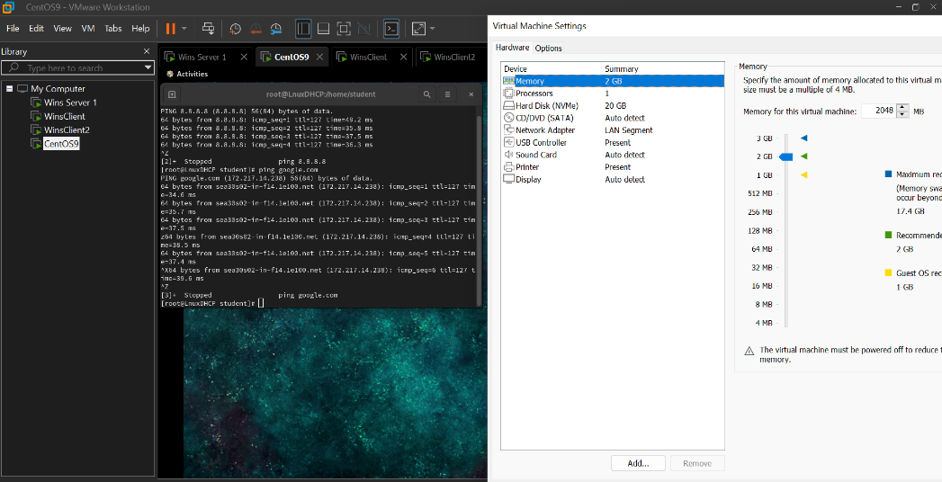

Contents of DHCP scope

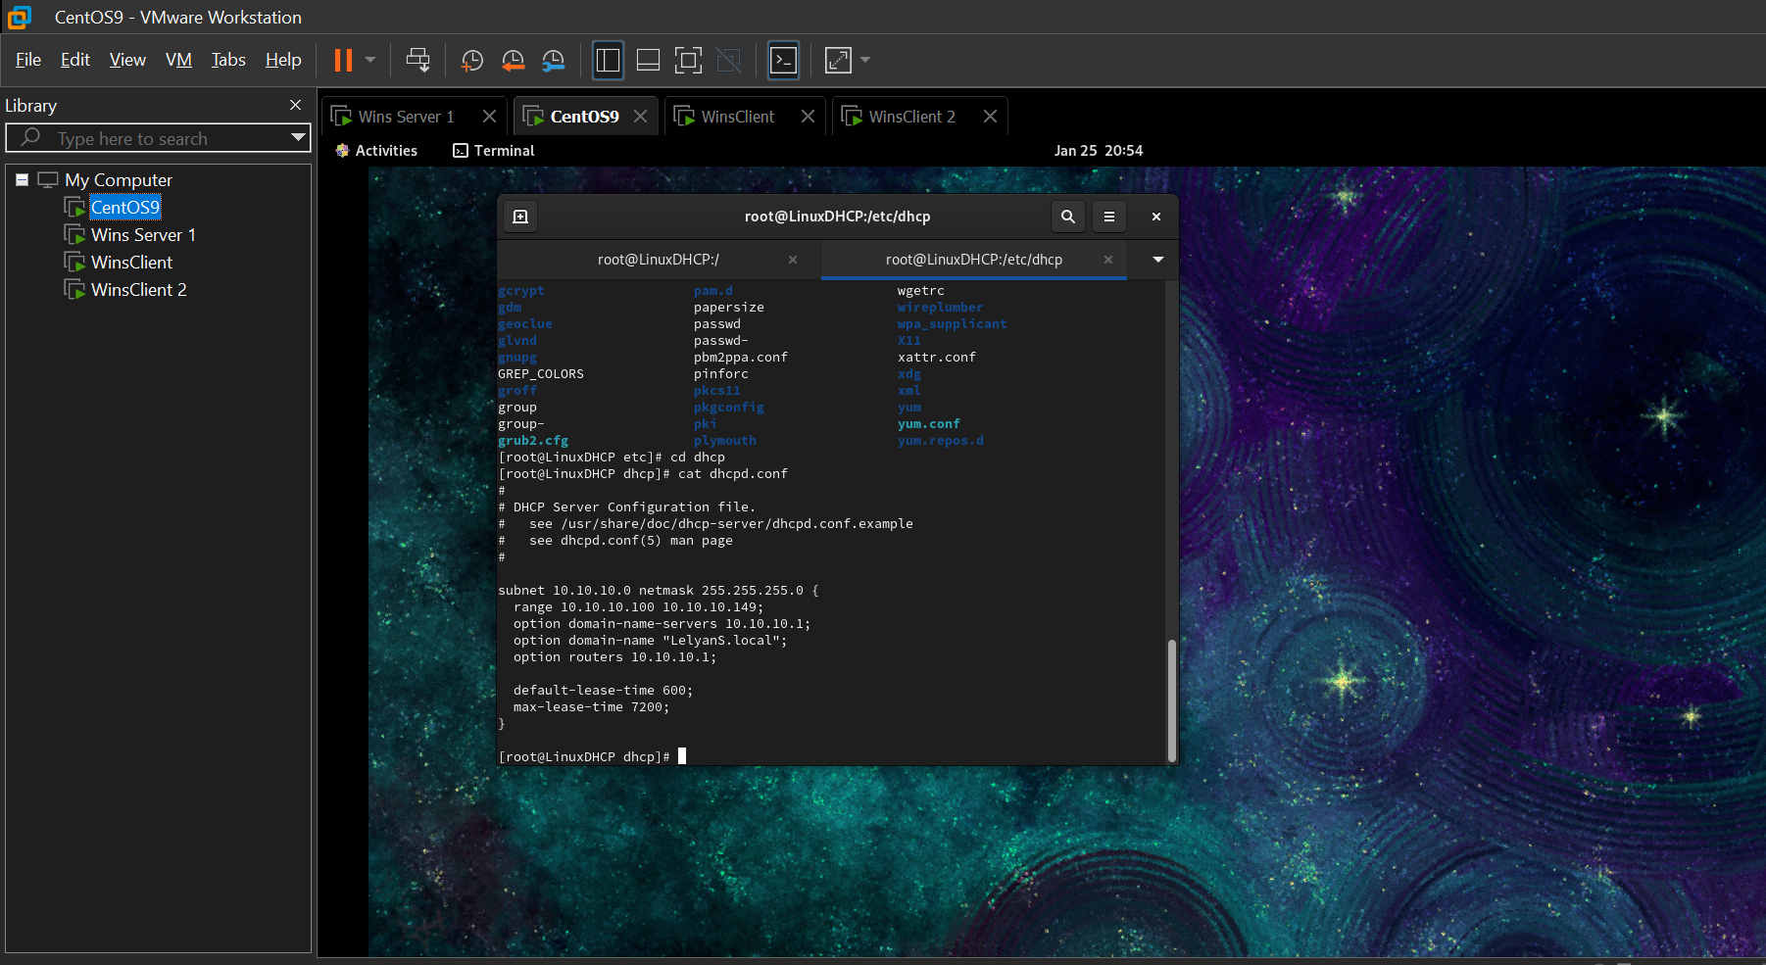

**Windows client 1**

Output of “ipconfig /all” command – showing DHCP server address and domain name

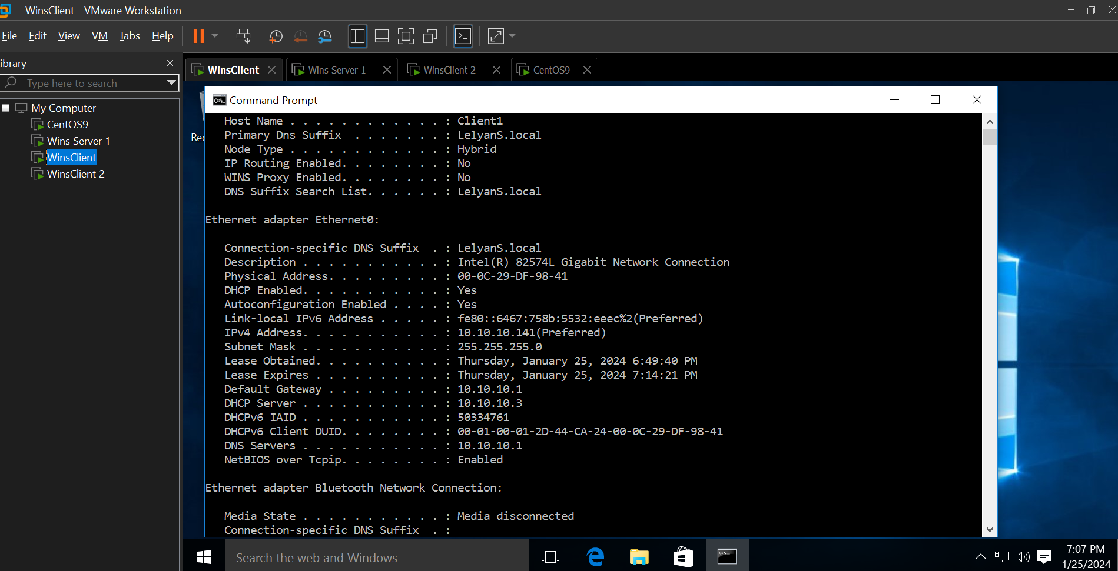

Output of “ping” to other Windows client and Windows Server by **name**

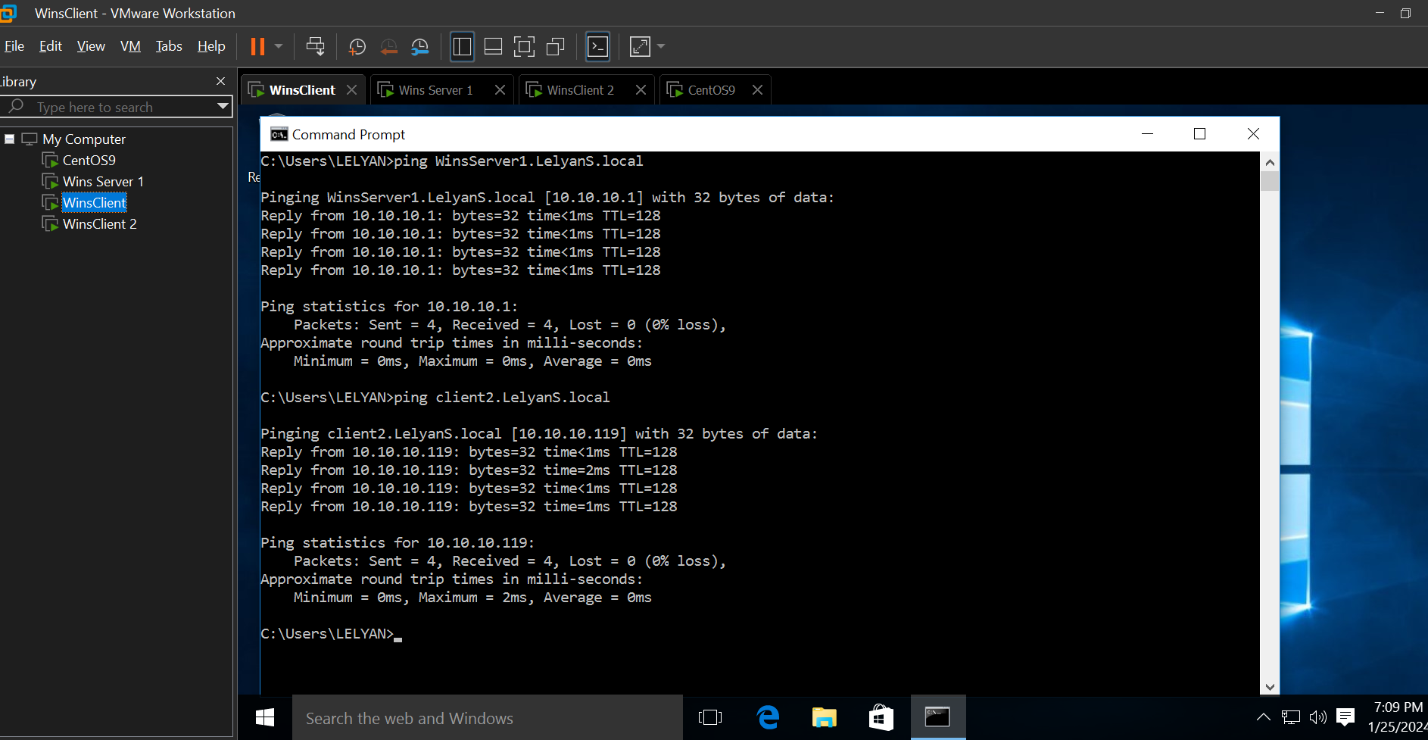

While logged in as one of the Domain users, the available mapped H: drive

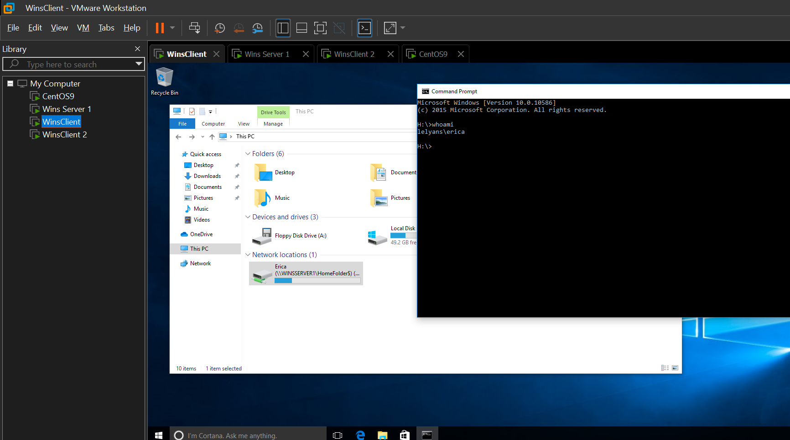

**Windows client 2**

Output of “ping” to Linux machine and other windows client both by **name**

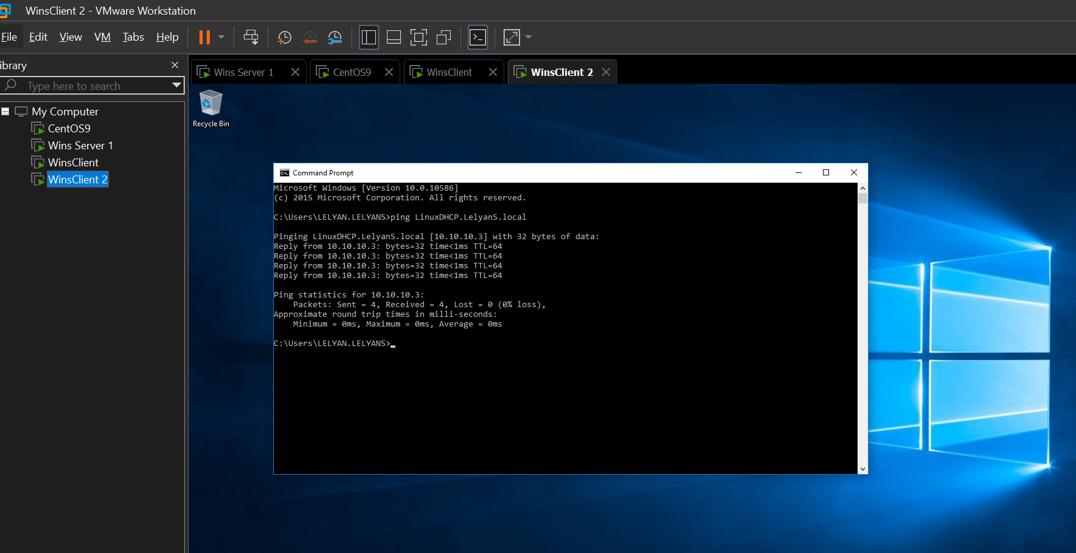

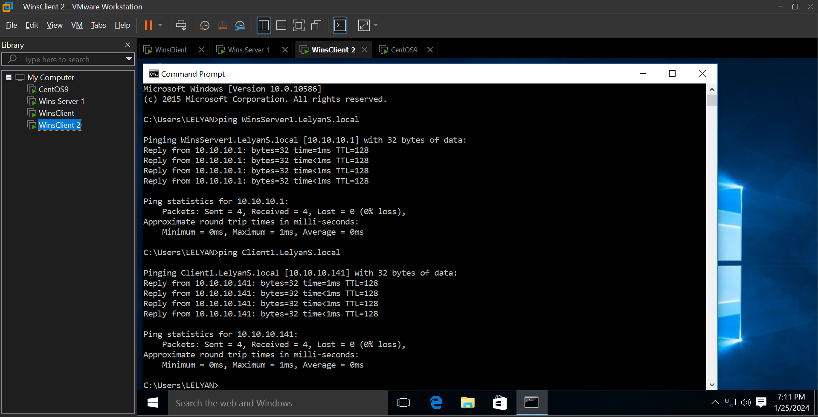

Demonstration of ability to reach Internet

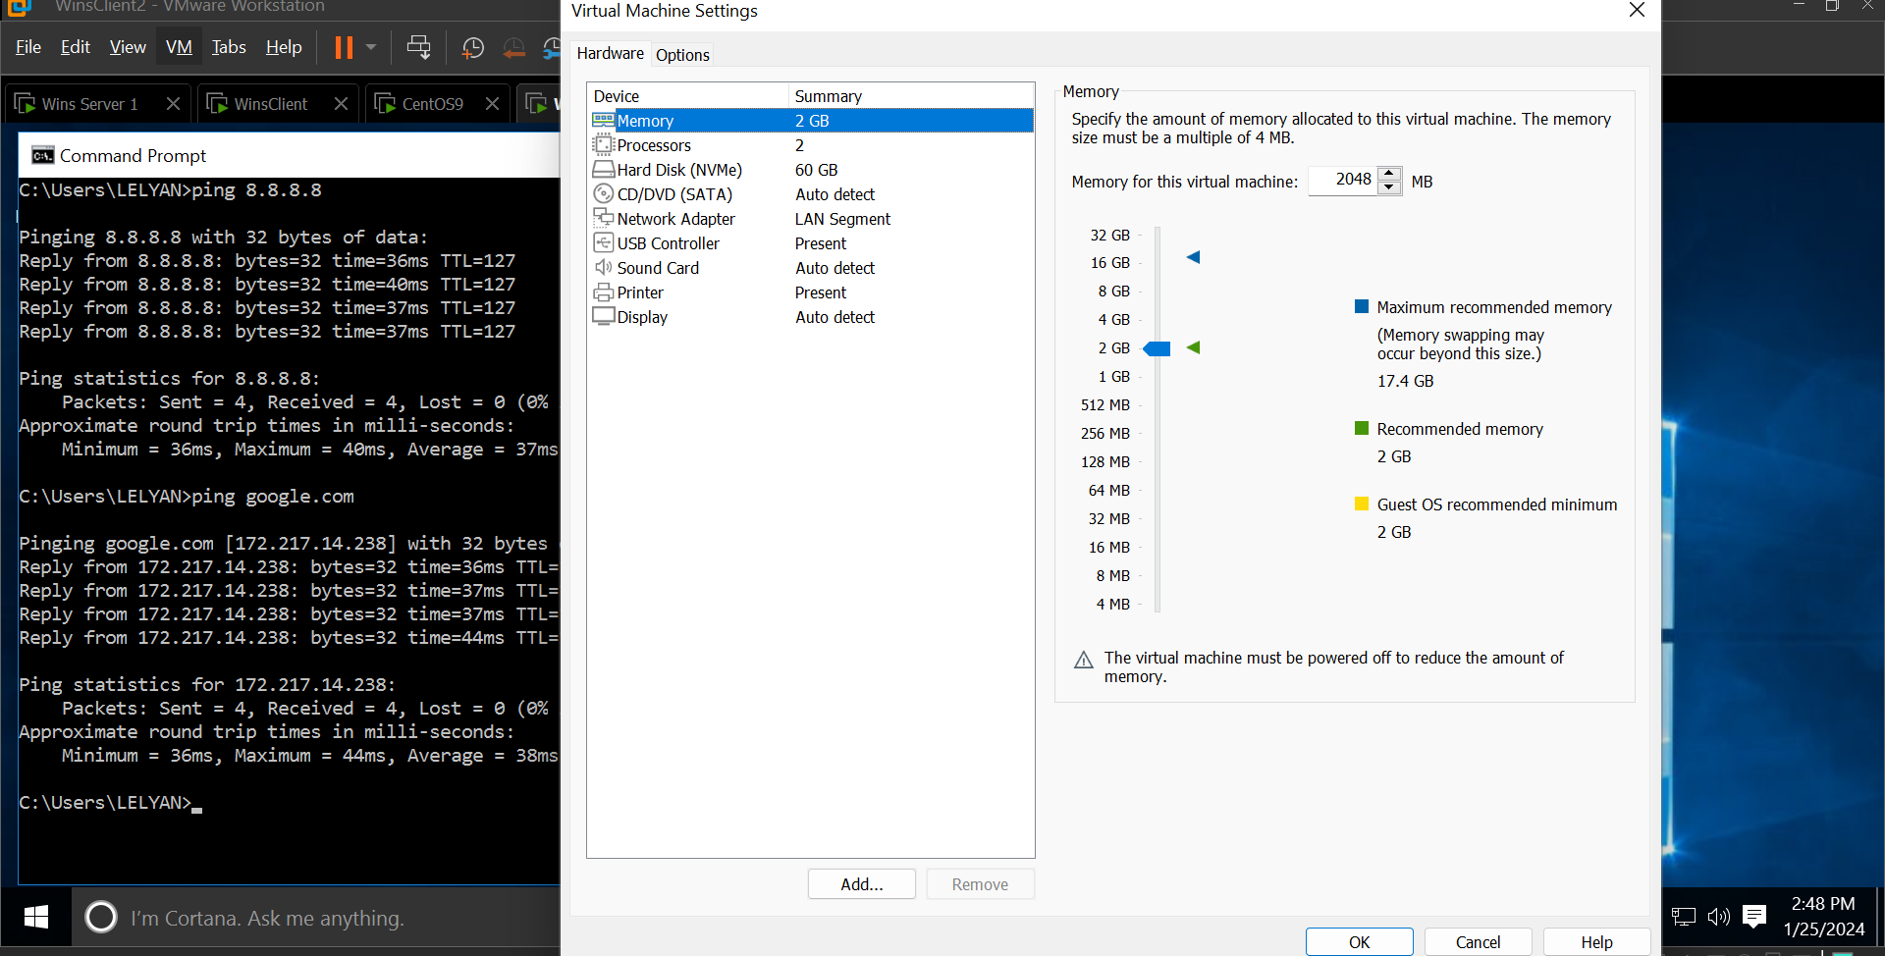

“whoami” command output while logged in as Domain user (different than the one displayed in Client 1)

